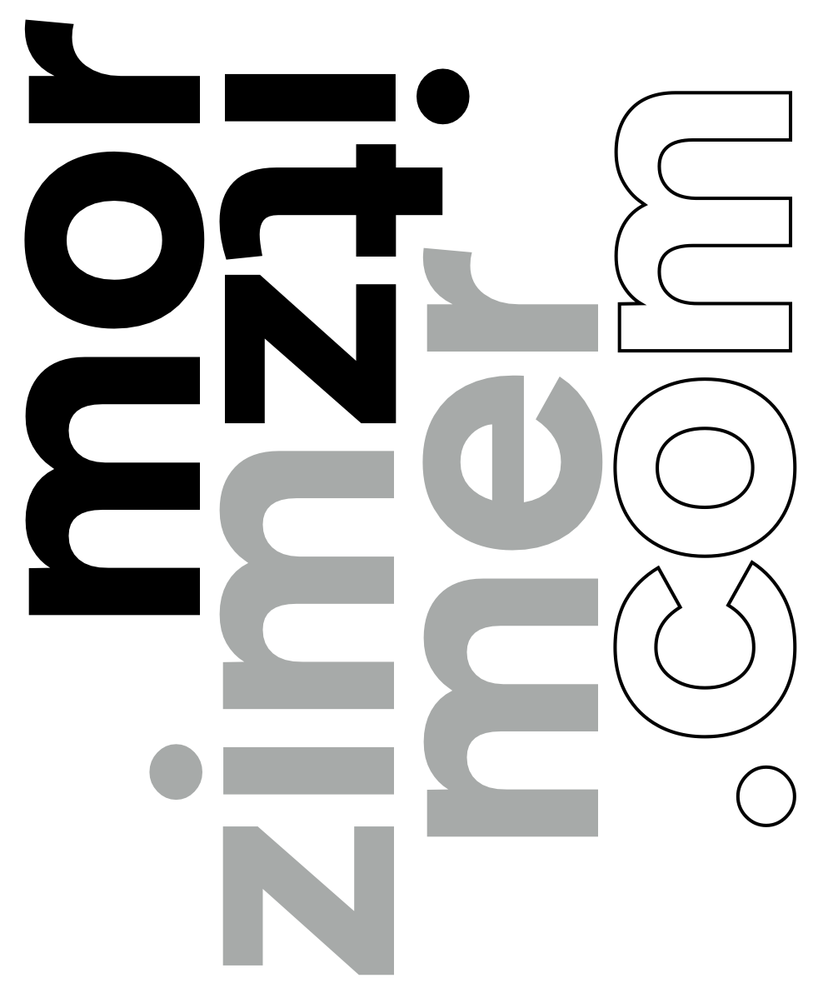  972.559.4323  moritz@moritz.blue | work history_  2017 – present  Lead Developer_ Mixed Media Creations  I lead a team of 3 developers, various contractors and designers, building and maintaining around 200 awesome websites of various sizes for a diverse clientele.  Designing and creating websites, UI, and custom typefaces. I am responsible for building modern WordPress themes, plugins and Multi-sites, working with open source, proprietary, and custom libraries, APIs and integrations: Google Maps, Availability Feeds, etc. Our products are accessible, fast, modern, beautiful, mobile-first, accessible websites and applications to achieve client’s conversion goals!  I collaborate closely with clients, project- and account-managers; acting as the liaison between departments and clients. Leading the team in production, UX and UI design, ensuring websites are fully usable, and WCAG accessible. By strategizing, creating new products, estimating and creating proposals and RFPs, I am also directly involved in business development.  2004 – present  Web Designer / Developer_ Self, moritzzimmer.com  Created, designed and developed beautiful, dynamic, SEO-optimized, accessible websites and web-apps for different small- and medium-sized clients from real-estate brokers to restaurants.  I also designed brand identities including custom typefaces, logos, and print collateral. Helping clients achieve their goals, make their visions become reality, and find the right voice and digital marketing channels for their brand.  2007-2017  Senior Store Manager_ Leslie’s Poolmart, Inc.  Exceeded sales-, customer service, profitability, and EBITDA goals in top performing stores. Received 14 national awards including MVP, top operations, and customer service. Supervised, hired, trained and built winning teams of up to 6 employees. Opened 2 new stores, and promoted 6 successful new leaders.  education_  2014-present_ Fort Hays State University  Web Development/ Information Networking & Telecommunications  Software Engineering, Usability Testing, Networking, Telecommunication and more. 4.0 GPA while working full time.  2005–2006_ University of Applied Sciences Darmstadt  Media Production  English-language classes on photography, management, programming, animation.

972.559.4323  moritz@moritz.blue | skills_  Programming & scripting languages_  HTML, CSS (HTML5, CSS3/4)  JavaScript, jQuery, Angular, ES6, Node, etc.  php, including WordPress, WP Multisite, Drupal  MySQL, and database design  Python, C, experience with compiled languages  Web development tools & processes_  WCAG Expert, web-accessibility standards and compliance  npm, composer, and various other package managers  SASS/SCSS, Gulp, and other processors and built pipelines  git, version control in production through Github, Bitbucket and more  reg-ex, in various applications  REST, SOAP, creation and usage of various APIs  LAMP, cPanel, WHM on CentOS, setup & maintenance of environments  Frameworks & libraries_  Creation and maintenance of various libraries  WordPress: Themes & Plugins, various public and private production plugins  Aframe, 3D and VR library applications  AngularJS  Bootstrap  Tailwind CSS  Software skills_  Adobe CC Suite, including Illustrator, Photoshop, InDesign, XD  Sketch, Figma, sketching, prototyping and collaborating  SublimeText , Brackets, vim, Visual Studio Code, Command Line  Glyphs.app, Birdfont, for font & typeface design and creation  MacOS, Windows, Linux, iOS, Android, DOS (OS proficiency)  Teamwork & work flow_  JIRA, Asana, Slack, Workamajig, G-Suite, work management tools  Responsive, dynamic & mobile design, including smart applications  SEO optimization & testing  Accessibility, compliance, ADA/WCAG, privacy, cookies  Usability testing & analysis  Cross-browser and device compatibility testing  Professional development_  Hired, trained and promoted up to 6 Employees at a time  Proven success in exceeding goals in challenging, competitive environments  Broad recognition based on many awards and accolades.  CS50 (HarvardX, edX)  jQuery DEV208x (Microsoft, edX)  HTML5.1x (W3Cx, edX)  Custom WCAG Training (web accessibility standards)

