 | work experience_  2022 – present  Principal Web Developer_ Sabre  Principal developer and designer of websites, applications and tools on Sabre’s global Brand Studio Team.  I lead the team that designs, builds and maintains the company's web presence and online marketing materials across all markets, working closely with stakeholders, product marketers and leadership up to ELT to ensure on-brand, on-time delivery of custom web assets and campaigns and brand strategy. Maintain and build the custom enterprise-level infrastructure our web stack runs on.  I also develop and maintain an array of internal tools custom-built on modern development frameworks: From custom Vue-based HTML Email Builders, Photo Libraries, QR-Code generation, to React project management tools.  2017 – 2022  Lead Developer_ Mixed Media Creations  I lead a team of 3 developers, plus various contractors and designers, building and maintaining around 200 awesome websites of various sizes for a diverse B2B clientele.  I was responsible for creating modern WordPress themes, plugins and multi-sites architectures, working with open source, proprietary, and custom libraries, APIs and integrations. Produced accessible, fast, modern, beautiful, mobile-first websites and applications to achieve client’s conversion goals.  Collaborated closely with clients, project- and account-managers; strategizing, creating new products, and being directly involved in business development.  2004 – present  Web Designer / Developer_ Self, moritzzimmer.com  Created, designed and developed beautiful, dynamic, SEO-optimized, accessible websites and web-apps either directly for small- and medium-sized businesses, or working as agency contractor, or freelancer for large companies like for audacy.com  2007-2017  Senior Store Manager_ Leslie’s Poolmart, Inc.  Exceeded sales-, customer service, profitability, and EBITDA goals in top performing stores. Received 14 national awards including MVP, top operations, and customer service. Supervised, hired, trained and built winning teams of up to 6 employees. Opened 2 new stores and promoted 6 successful new leaders.  education_  2014-present_ Fort Hays State University  Web Development/ Information Networking & Telecommunications  Software Engineering, Usability Testing, Networking, Telecommunication and more. 4.0 GPA while working full time.  2005–2006_ University of Applied Sciences Darmstadt  Media Production  English-language classes on design, art, photography, management, animation.
  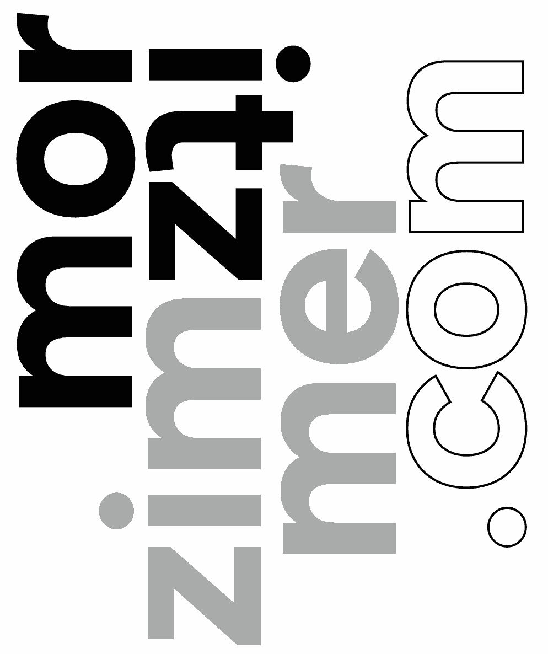
  972.559.4323
  Moritzzimmer484@
  gmail.com

 | skills_  Programming & scripting languages_  HTML5, CSS/SASS/SCSS  Modern JavaScript development and application design:  React, VueJS, ES6, Node, NextJS, Angular, etc.  php, including modern React-WordPress, WP Multisite, Drupal  MySQL, and custom database design  Python, C, C# (experience with compiled languages)  Web development tools & processes_  Certified WCAG Expert, web-accessibility standards and compliance  npm, composer, and various other package managers  git, version control in production through Github, Bitbucket and more  reg-ex, in various applications  REST, SOAP, design, creation and consumption of various APIs  LAMP, cPanel, WHM on CentOS, setup & maintenance of environments  GCP & GCS dev/cert/prod deployment pipelines  Frameworks & libraries_  Creation and maintenance of various libraries  WordPress: Themes & Plugins, various public and private production plugins  Aframe, 3D and VR library applications  Software skills_  Adobe CC Suite, including Illustrator, Photoshop, InDesign  Figma, wireframing, prototyping and collaborating  Visual Studio Code , SublimeText, vim, bash, szh, etc.  Glyphs.app, Birdfont, for font & typeface design and creation  MS Copilot, Google Gemini & ChatGPT prompt based programming  Teamwork & work flow_  JIRA, Asana, Slack, Workamajig, G-Suite, work management tools  Responsive, dynamic & mobile design, including smart applications  SEO optimization & testing  Accessibility, compliance, ADA/WCAG, privacy, cookies  Usability testing & analysis  Cross-browser and device compatibility testing  Professional development_  Hired, trained and promoted up to 6 Employees at a time  Proven success in exceeding goals in challenging, competitive environments  Broad recognition based on many awards and accolades.  CS50 (HarvardX)  jQuery DEV208x (Microsoft, edX)  HTML5.1x (W3Cx, edX)  Certified WCAG Expert (web accessibility standards)
  972.559.4323
  moritzzimmer484@
  gmail.com

